**Project Plan**

**GCF Website Revamp**

| Industry Partner | GCF Toronto |
| --- | --- |
| Primary Instructor | Anjana Shah |
| Team Member | Phoenix Armand Ani |
| Team Member | Do Huynh |
| Team Member | Minh Nhat Vo |
| Team Member | Jacob Solano |

Document Revision History

| Revision # 1.0 | Date |
| --- | --- |
|  |  |

**Table of Contents**

**1. Executive Summary** **3**

**2. Project Approvers, Reviews and Distribution List** **3**

**3. Scope** **4**

**4. Deliverables** **4**

**5. Assumptions** **4**

**6. Dependencies** **5**

Internal Dependencies: 5

External Dependencies: 5

**7. Risk Management** **5**

**8. Communication** **6**

Reporting 6

Meetings 6

**9. Task Listing (WBS- Work Breakdown Structure)** **6**

**10. Gantt Chart** **8**

**11. Milestones** **9**

**12. RAM – Responsibility Assignment Matrix** **9**

**13. Approval** **10**

# 1. Executive Summary

| Objective | The main objective of this project is to turn an existing website to a web application for a church called Greenhills Christian Fellowship or also known as GCF. This new web application will be re-designed to be responsive on various types of devices and consist of some additional features that the church is required to have. |
| --- | --- |
| Corporate Goals Addressed | * Provide detailed documents about how the application will be created, team members’ responsibilities, project’s scope as well as all requirements in order to make the application fully functional * Final product should meet all the criterias that have been discussed and agreed upon. It should meet the deadline as well. |
| Planned Start Date | October 21, 2022 |
| Planned End Date | December 31, 2022 |

# 2. Project Approvers, Reviews and Distribution List

| Project Role | Name | E-mail | Date |
| --- | --- | --- | --- |
| Primary Instructor | Anjana Shah | ashah@georgebrown.ca | October 7, 2022 |
| GCF Team Member | Phoenix Armand Ani | phoenixarmand.ani@georgebrown.ca | October 7, 2022 |
| GCF Team Member | Do Huynh | Do.Huynh@georgebrown.ca | October 7, 2022 |
| GCF Team Member | Minh Nhat Vo | minhnhat.vo@georgebrown.ca | October 7, 2022 |
| GCF Team Member | Jacob Solano | jacob.solano@georgebrown.ca | October 7, 2022 |
| Project Lead | John Greg Austria | john.austria@hotmail.com | October 10, 2022 |
| Project Supervisor | Hide Kang | Not Present | Not Present |
| GCF Chairman | Joshua Sinena | joshuasinena@gmail.com | October 10, 2022 |

# 3. Scope

Define the sum total of all of its products and their requirements or features.

| In Scope | Out of Scope |
| --- | --- |
| Task Splitter | Extra-cost |
| Personal workstation | Additional features |
| IDEs and Text Editors | New technology version |
| Version Control System | Change of deadlines |
| Communication Channels | Managing the website after project is delivered |

# 4. Deliverables

| Deliverable | Description |
| --- | --- |
| Responsive Web application | The web application interface will be user-friendly and responsive in multiple devices with different screen ratios. |
| Administrator rights | Administrators who have been given the rights to make changes to the app can perform any type of changes according to their needs and likes. |
| UI prototype | A prototype website that would be showing the basic UI elements to stakeholders using Figma |
| Mockup application | A mockup application that has most or all features but not ready for release. |

# 5. Assumptions

* Project Owner will provide extra funding to the project whenever it requests after taking consideration of the necessity and possibility of the request.
* The deadlines of the project can be extended.
* Web applications will be created using Wordpress and its plug-ins to create a responsive and secure website.
* All content such as about-us information, images, data and databases are available for the new application.
* SFTP, SSH, WP-CLI will be used to defend from cyberattacks and minimize security issues.

# 6. Dependencies

## Internal Dependencies:

* Every team member will have different work stations which makes the code and other related softwares dependent on personal work stations.
* Time and availability of each member is different so that everyone has to agree to have meetings on specific days.

## External Dependencies:

* Project funding will be approved by the GCF chairman and Project Supervisor according to every project request.
* Functionalities and features of the application will be reviewed by Project Lead and Project Supervisor in order to be approved to implement.
* In case of extending the deadline, the GCF chairman will consider the possibility to make the extension based on the current work progress.

# 7. Risk Management

| Potential Risk | Severity (H/M/L) | Likelihood (H/M/L) | Management Strategy |
| --- | --- | --- | --- |
| Unable to connect to database | H | H | Do Huynh |
| Failed using 3rd party for donation feature | H | H | Phoenix Armand Ani |
| Unable to upload images to the log activities | L | L | Do Huynh |
| Weak security on the donor’s information | H | M | Do Huynh |

# 8. Communication

## Reporting

| Report | Audience | Frequency |
| --- | --- | --- |
| Work Progress Report | Project Lead, Project Supervisor and GCF Chairman | At the end of every week |

## Meetings

| Meeting | Purpose | Attendees | Frequency |
| --- | --- | --- | --- |
| GCF meeting | Discuss the current work progress | Do Huynh, Jacob Solano, Minh Nhat Vo, Phoenix Armand Ani, Project Lead and GCF Chairman | Every week |

# 9. Task Listing (WBS- Work Breakdown Structure)

| Reference | Tasks | Duration | Dependency |
| --- | --- | --- | --- |
| A | Create Prototype Website | 7.5 hours | 1 |
| A | Plan and visualize | 1 hour | 1.1 |
| A | Design prototype website with basic UI elements using Figma | 2 hours | 1.1.1 |
| A | Present prototype website to stakeholder | 0.5 hour | 1.1.1.1 |
| A | Evaluate topics of improvement with stakeholder | 1 hour | 1.1.1.1.1 |
| A | Finalize and deliver prototype website to stakeholder | 3 hours | 1.1.1.1.1.1 |
| B | Create Mock-up application (Beta version of website) | 63 hours | 2 |
| B | Plan and visualize | 2 hour | 2.1 |
| B | Design basic website using Wordpress | 6 hours | 2.1.1 |
| B | Add functionality to the website (user management, media management, database management, social media functionality, newsletter functionality, donation functionality) | 15 hours | 2.1.1.1 |
| B | Test functionalities and patch bug fixes | 20 hours | 2.1.1.1.1 |
| B | Test responsiveness on multiple devices and patch bug fixes | 8 hours | 2.1.1.1.2 |
| B | Present mock-up application with stakeholder | 0.5 hour | 2.1.1.1.1.1 |
| B | Evaluate topics of improvement with stakeholder | 1.5 hours | 2.1.1.1.1.1.1 |
| B | Finalize and deliver prototype website to stakeholder | 10 hours | 2.1.1.1.1.1.1.1 |
| C | Create a Release notes file | 2 hours | 3 |
| C | Document each change and bug fixes to the website | 1.5 hours | 3.1 |
| C | Proofread documentation | 0.5 hours | 3.1.1 |
| C | Deliver release notes to Stakeholder | 0 hour | 3.1.1.1 |
| D | Create Website Management Instructions file | 4 hours | 4 |
| D | Write basic instructions for the administrators to read in order for them to use the website | 2 hours | 4.1 |
| D | Proofread instruction file | 0.5 hour | 4.1.1 |
| D | Evaluate topics of improvement with stakeholder | 0.5 hour | 4.1.1.1 |
| D | Finalize instruction file and deliver instructions to stakeholder | 1 hour | 4.1.1.1.1 |
| E | Create Release Version of website | 40 hours | 5 |
| E | Evaluate topics of improvement with stakeholder on mock-up application | 2 hours | 5.1 |
| E | Improve the functionality and design based on feedback | 18 hours | 5.1.1 |
| E | Finalize release version and deliver to stakeholder | 20 hours | 5.1.1.1 |
|  |  |  |  |
|  |  |  |  |
|  |  |  |  |
|  |  |  |  |
|  |  |  |  |

# 

# 10. Gantt Chart

# 

# 11. Milestones

| Major Activity or Milestone | Estimated Milestone Target date | Owner/Reviewer Team Members |
| --- | --- | --- |
| Meeting with the Stakeholder through Zoom for the second time to report how the process is going to be. | October 9, 2022 | Phoenix Armand Ani |
| First time meeting Stakeholder in person to discuss about features website’s | September 25, 2022 | Phoenix Armand Ani |
| Regroup to search and build basic ideas for the church website. | September 11, 2022 | Do Huynh |

# 12. RAM – Responsibility Assignment Matrix

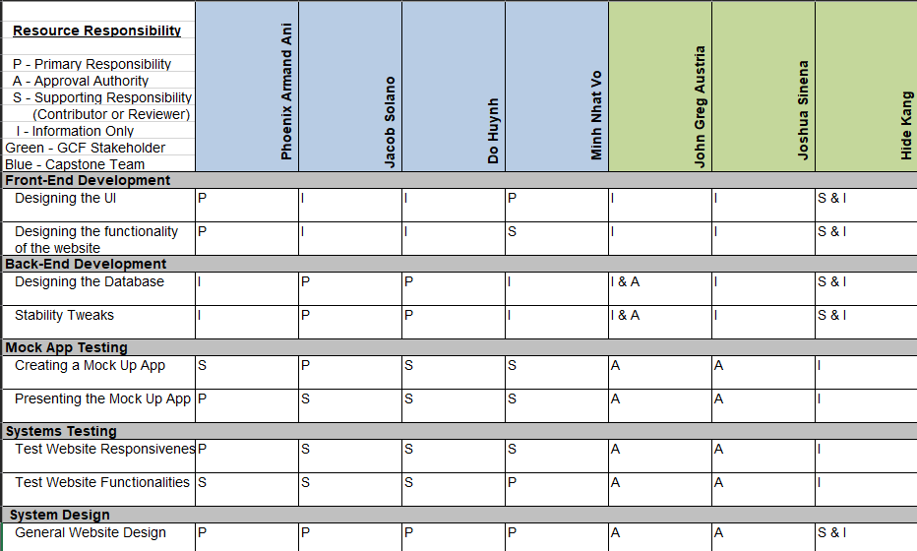

# 13. Approval

The signatures below indicate their approval of the contents of this document.

| Project Role | Name | Signature | Date |
| --- | --- | --- | --- |
| Capstone Team Member | Phoenix Armand Ani | Phoenix Armand Ani | October 11, 2022 |
| Capstone Team Member | Do Huynh | Do Huynh | October 11, 2022 |
| Capstone Team Member | Minh Nhat Vo | Minh Nhat Vo | October 11, 2022 |
| Capstone Team Member | Jacob Solano | Jacob Solano | October 11, 2022 |
| GCF Stakeholder | Joshua Sinena | Joshua Sinena | October 10, 2022 |
| GCF Stakeholder | John Greg Austria | John Greg Austria | October 10. 2022 |